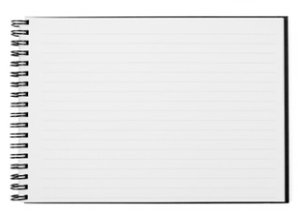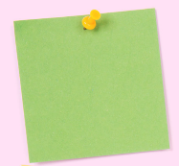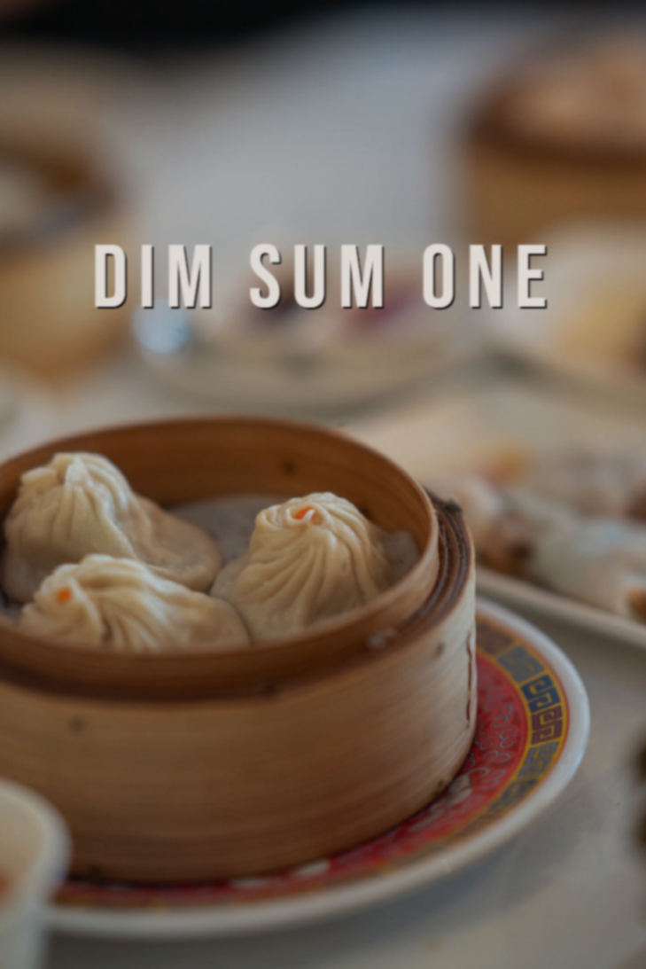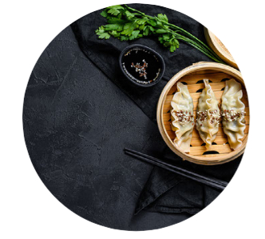



*How did the dining hall* ***look?***

*What could you* ***see?***

*What* ***sound*** *did you* ***hear?***

I liked the environment though it was a bit noisy. The dining hall looked nice with some lanterns.

*How did the spring rolls* ***look*** *and* ***taste?***

*What was the* ***texture*** *of the spring rolls?*

*How did the vinegar* ***smell****?*

What a disappointment!!! (7 days ago)

**Chris**



A place is more than what you can SEE. Keep your mind open and try to HEAR, SMELL, TASTE and FEEL it.

Task 2: Revise Sam’s dining review by adding more **sensory descriptions** to help readers understand his excitement. The sticky notes and symbols may help you.



An amazing dining experience (6 days ago)



**Sam**

**smell of** **food and drinks**

* **fruity, garlicky, lemony, minty, peppery, smoky**
* The food/drinks smelt **aromatic/fragrant/ refreshing**.
* The food/drinks had a/an **pungent/ revolting/rancid/unpleasant** smell.

Curriculum Development Institute

Education Bureau HKSAR ©2022

Task 3: Chris had a terrible dining experience at *Dim Sum One*last week. Write a short review on the dining environment and food for him/her.



***Dim Sum One***

Task 1: Complete the bubbles below with words to describe what you could **see**, **hear**, **smell**, **taste** and **feel** at *Dim Sum One*.

***Topic***

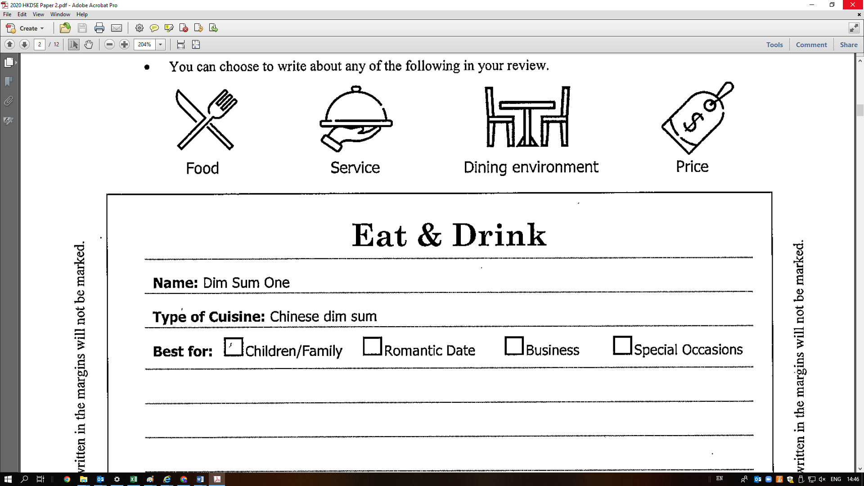

*Writing topic taken from Paper 2 of the 2020 HKDSE English Language Examination ©HKEAA*

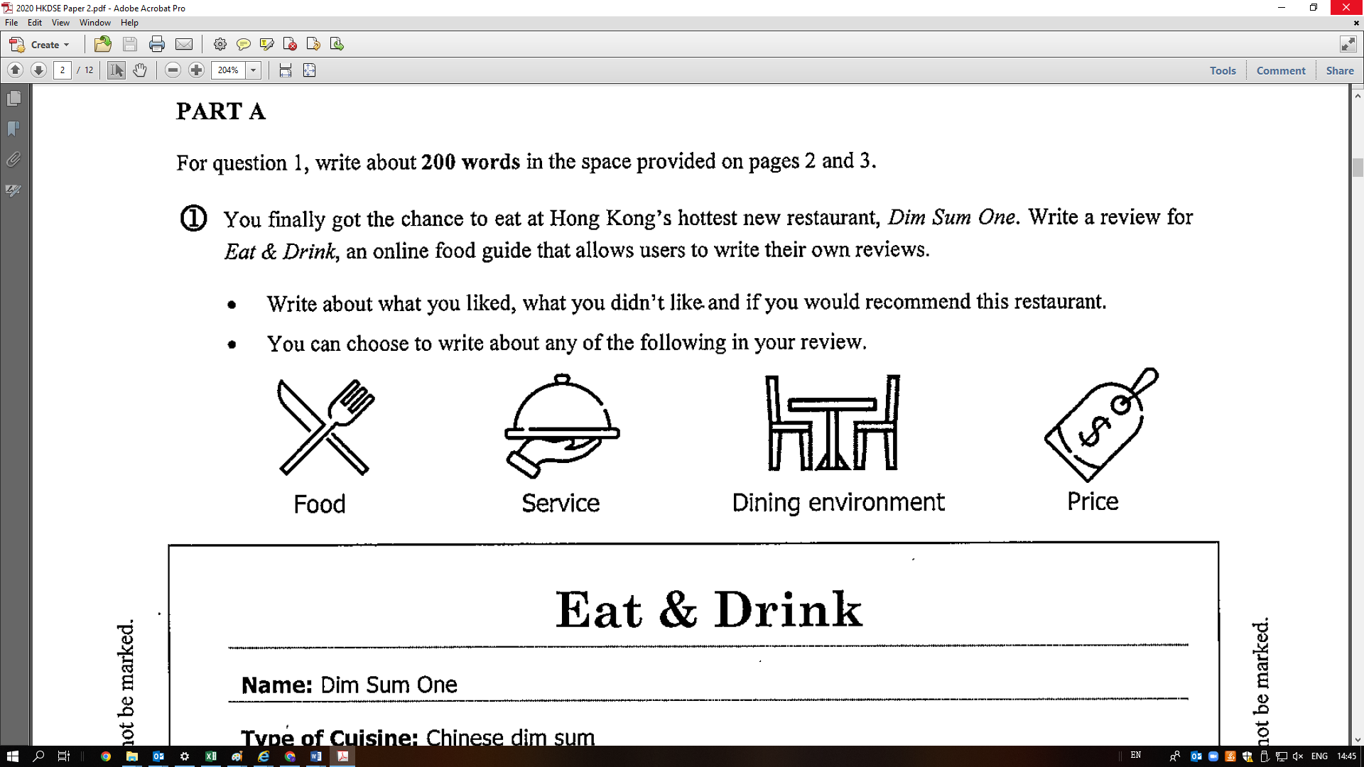



I visited *Dim Sum One* last week. The dining hall was pretty small. At the time I arrived, it was _**jam-packed**_ with customers sitting back to back. The _**deafening**_voices of diners filled the whole restaurant and definitely ruined my appetite.

I only ordered the signature dishes – spring rolls and baked barbecued pork buns. To my disappointment, the spring rolls were not _**crunchy**_ at all. They were so _**soggy**__ and _ **oily**  that I could tell they were prepared hours ago. The baked barbecued pork buns were no better. They were _**cold**_ , _**bland** _ and __ **hard**_ _ as rocks. I wondered why people recommended them and described them as ‘steaming hot and tasty with a crispy top’! What’s worse, the filling smelt _ **rancid** _ and I spat the meat out in disgust after the first bite. I complained to the manager and swore that I would never set foot in this restaurant again.



I liked the food, too. The spring rolls were really yummy. They went well with the vinegar dip.



I liked the environment. The dining hall was **brightly-lit**  with rows of **flaming red** lanterns hanging down from the ceiling. The _ **buzzy**___ atmosphere made the place an ideal location for gatherings with family and friends. Though sometimes it could get a bit too _ _ **noisy** _ _ for me tohear my friends clearly, I think that’s typical of a popular Chinese restaurant.

The food did not disappoint me. The _**golden-brown**_ spring rolls were so **scrumptious** . They were_ **crispy**_ on the outside and_ **moist** on the inside. The vinegar dip might smell a bit _ **pungent**__ , but it was a perfect match for the spring rolls and increased my appetite.



Suggested answers only



***The texture and temperature*** *of food and drinks can be felt by* ***hand*** *and* ***mouth.***

**texture and temperature of food and drinks**

- **buttery, fizzy, flaky, fluffy, foamy, moist, spongy**

- **steaming hot, lukewarm, icy cold**

- **crispy, crunchy, juicy, silky, tender**

- a piece of **succulent** meat

- The soup was **smooth** and **creamy**.

- The food was **oily**, **soggy** and **tough**.

- I didn’t like the **chewy/rubbery** texture of

the meat.



**Sam’s draft dining review:**

**décor, colour of furniture, food presentation**

* a **brightly-lit** dining hall with **flaming red** lanterns
* **freshly-fried golden brown** crab cakes
* the restaurant was **jam-packed** with

people

* a **charred** pork chop



**environment and human noise/sounds in the restaurant**

* a **buzzy** atmosphere with people **chatting and**

**laughing**

* **melodious/relaxing/rhythmic traditional Chinese**

**instrumental** music

* the **deafening/ear-splitting** voices
* **clashing and breaking/shattering** of plates

and cups

**taste and flavour of food and drinks**

- **bitter, mellow, savoury, spicy, tangy, tart**

- the **briny tang/flavour** of the scallops

- the **winey taste** of the drunken chicken

- The food was **appetising/delectable/finger-licking/palatable/refreshing/scrumptious**.

- I found the dish too **bland/gamy/fishy.**

-The food tasted **awful/disgusting**.